**Work- Case №5**

*Performed by students of the group РПЗ 93-Б*

*Скворцов Дмитро, Бушовська Ольга, Білобровенко Олександра*

**Task 1:**

***Готував матеріал студент Скворцов Дмитро***

1. Mounting in Linux allows you to access the contents of the disk and organize the structure of the file system. Mounting also lets you work with a disk image (for example, created with the dd program), as well as open and edit a wide variety of file systems and disk images (for example, virtual machine disk images); even remote network directories can be mounted, making them available as if they were files on any other local storage.

In addition to the fact that you can work with disk images using mount, the correct mount settings are necessary for the computer to which the disk for forensic analysis is connected - for example, this disk should not be automatically mounted with write permissions (so as not to be corrupted).

In Linux, there is such a thing as "mounting" a disk. To access the files on this drive, you must first mount it. The question may arise, why such difficulties? Mounting is a powerful thing that allows you amazing flexibility in setting up the file system!

***Готувала матеріал студентка Білобровенко Олександра***

1. If you connect a camcorder to a Linux computer, you can download input data from /dev/video0 or a similar device. Everything you need can be found in **/dev**, and it is always the shortest path from point A to point B.

And on Windows, for example, Connecting to non-OS systems is always a maze of SDKs, closed-source libraries, and sometimes privacy agreements. The situation, of course, is not the same everywhere, it depends on which platform the programmer writes the code for, but it is difficult for other systems to argue with the simplicity and predictability of the Linux interface.

**Task 2:**

***Готувала матеріал студентка Бушоввська Ольга***

The essence of mounting is that a new directory (a regular folder) is created in the file system, for example, this is the **/mnt/disk_d** folder. And then the mount command indicates that now, for example, the **/dev/sda** disk is mounted to the **/mnt/disk_d** directory. After that, you can access the files on the **/dev/sda** disk by opening the **/mnt/disk_d** folder in any file manager:

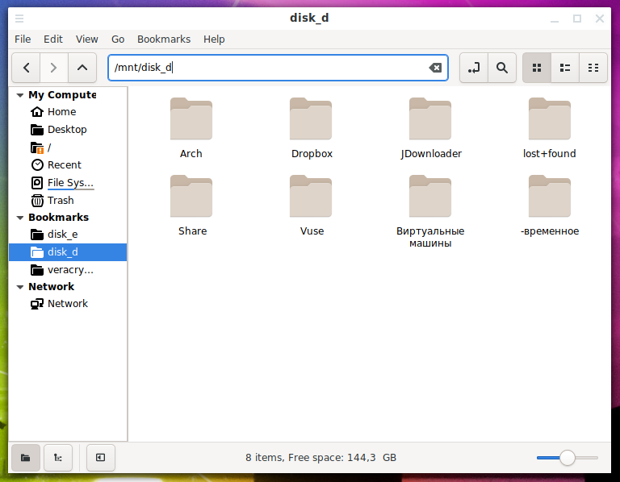

***Picture 2.1***

**Conclusion:** During this Work Case, I learned some interesting aspects of connecting peripherals to a Linux computer and how this system (Linux) interacts with peripherals.